Project Design Phase-I
Solution Architecture

Date | 28 October 2026
Team ID | Individual Project
Global Electric Vehicle Market Intelligence Dashboard | Global Electric Vehicle Market Intelligence Dashboard
Maximum Marks | 4 Marks

Solution Architecture:
Solution architecture is a complex process – with many sub-processes – that bridges the gap between business problems and technology solutions. Its goals are to:
- Find the best tech solution to solve existing business problems.
- Describe the structure, characteristics, behavior, and other aspects of the software to project stakeholders.
- Define features, development phases, and solution requirements.
- Provide specifications according to which the solution is defined, managed, and delivered.

Sample Solution Architecture Diagram:
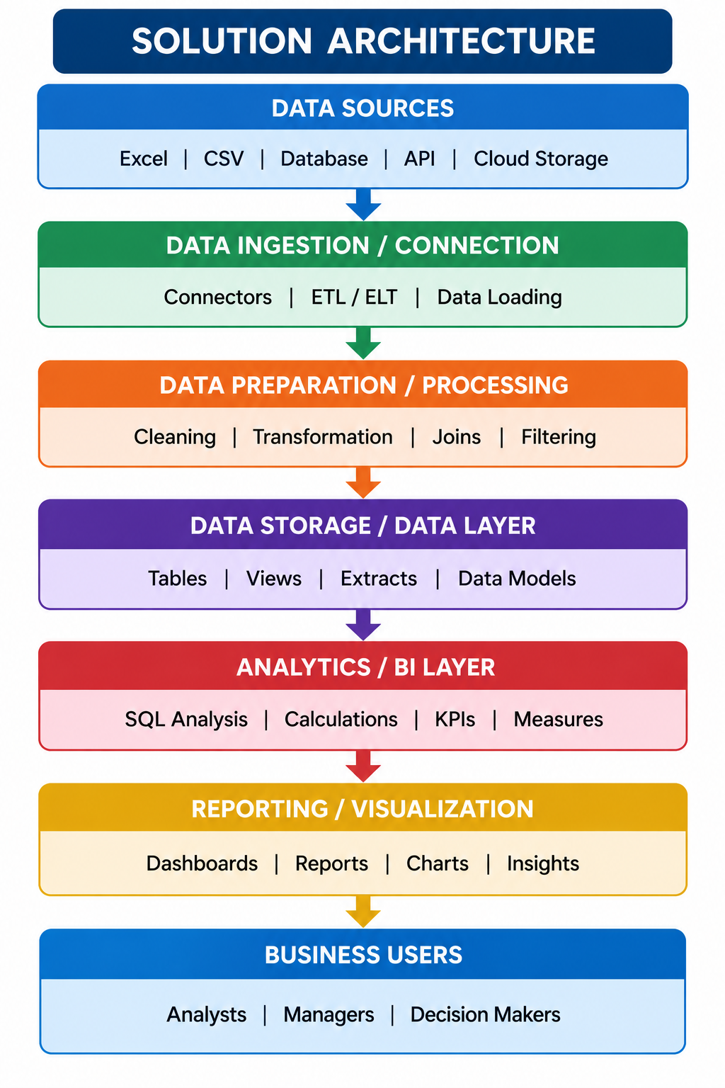

Component Description Table
Component Name | Description / Role in Architecture | Technology Used

EV Dashboard Architecture
1. Data source layer: licensed/public EV dataset containing available vehicle, sales, battery, range, country, and rating attributes.
2. Data quality layer: inspect schema, data types, nulls, duplicates, category labels, units, and time coverage. Preserve a raw copy.
3. Analysis layer: Tableau calculated fields and aggregations; optional SQL/Python preparation only if needed.
4. Visualization layer: KPI cards, annual sales trend, category/manufacturer rankings, battery mix, range comparison, country analysis, and ratings.
5. Interaction layer: year/category/manufacturer/battery/country filters, tooltips, and guided Tableau story.
6. Validation and delivery: reconcile values to source data, test filter behavior, record performance, document limitations, then save or publish only if supported.
Security and governance: use permitted data, do not embed credentials, cite the source, and disclose missing or non-comparable fields.
Student: Ansh Shrivastava
Project: Global Electric Vehicle Market Intelligence Dashboard

